Day in the Life of the Hudson River 10/13/22
Henry Hudson Riverfront Park, Hudson, NY
RIVER MILE: 117
Salt Front: ~ RM 76
Clearwater Chloe Grey Smith & crew
Chatham High School– Sandi Fischer - 36 students & 9 adults
Latitude 42.25369°N & Longitude – 73.79935°W
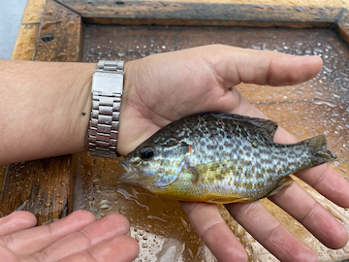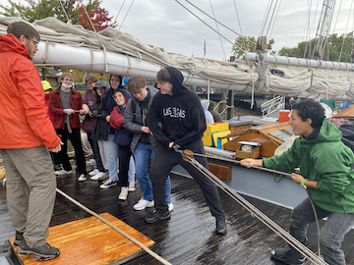
Location: Henry Hudson Riverfront Park, Hudson, NY & on Clearwater Boat
Area: Inlet by the parking lot at the boat ramp on the north end of the park
Sampling Site: Altered banks, ripraps (large rocks), covered vegetation
Surrounding Land Uses: Urban/Residential; Industrial/Commercial; Forested
Shoreline: 100% Rocky
River Bottom: Muddy
Water: Calm
Plants in the Water: duckweed and water chestnuts
*NR = Not read/recorded
ITEM |  | Time |  | Reading |  |  |  | Comments
Physical
Air Temperature- |  | 9:33 AM |  | 17.2°C |  |  | 63°F
Wind Speed: |  | 10:00 Am |  | Anemometer  5 mph |  |  | Beaufort  2 | Direction  S/SW
Weather today |  | 9:30 AM |  | >75% cloud cover |  |  | Start & Stop Rain
Weather the past 3 days: |  | Overcast & relatively warm for the time of year-50s and 60s- light wind but heavier than the day before out of the south; some showers on 10/11
Tides- |  | Time |  | Rising, Falling, Unchanged |  |  | Water Height (cm)
 |  | 9:35 AM |  | Falling |  |  | 51.8 cm
Current- NR |  | Time |  | Cm/sec |  | Knots | North/South | Ebb/Flood/Still
Water Temperature- |  | 11:15 AM |  | 15°C |  |  | 59°F
Turbidity- Long Sight Tube (120 cm) |  | 10:48 AM |  | 71.5 cm
Chemical
Salinity-LR Quantab |  | 10:09 AM |  | 52 ppm |  |  | 1.4 quantab reading | 29 ppm Cl-
Standardized Salinity – LR Quantabs |  | 5:04 PM |  | 92 ppm |  |  | 2.0 quantab reading | 51 ppm Cl-
DO – Hach Drop Count Kit |  | Time  10:55 AM |  | Temp  15°C |  |  | ppm DO  11 ppm | % saturation  110%
pH – Color Match Kit |  | 10:01 AM |  | 7.5
Nitrates- NR
Phosphates- NR
Alkalinity- NR
Biological-
Fish – Seine |  | Number |  | Name |  |  | Length of longest | Length of smallest
8:00 AM-9:45 AM – 3 hauls |  | 1 |  | Pumpkinseed |  |  | 13 cm
Fish Totals |  | TOTAL: 1 |  | Diversity: 1
Macroinvertebrates |  | Number |  | Name |  |  | Length of longest | Length of smallest
Macroinvertebrate Totals |  | TOTAL: 0 |  | Diversity:0
Sediment Core – NR
Length | H2S smell |  | Oxid Top |  | Oil |  | Grain Size | Other Features
Boats-
 | Time |  | Name |  | Color |  | North/Southbound | Light/Loaded
Commercial | 9:40 AM  9:52 AM  11:44 AM |  | Barge  Cruise Ship  Barge |  | Red, black & turquoise  White  Yellow and red |  | Southbound  Southbound  Southbound | Light  Light  Light
Recreational | 10:50 AM  11:45 AM |  | Sailboat  Powerboat |  | White  Blue |  | Southbound  Northbound | NR  NR

